Lab Report No 2

Understanding and implementing key concepts of AI
Artificial Intelligence



Submitted By:
[Huzaifa Shahbaz]
[21-CE-009]
[Aqsa Shah]
[21-CE-039]

Submitted to:
Engr. Hareem Khan
Dated:
4thMar,2025

Department of Computer Engineering,
HITEC University, Taxila
Lab Example No 1:

Solution:
Brief description (3-5 lines)
Regression theory is a statistical method used to model the relationship between a dependent variable and independent variables, aiding in prognosis, trend detection, and correlation analysis. It is applicable in machine learning, economics, and engineering for data-based decision-making in various fields.
The code
# Import necessary libraries
import numpy as np
import pandas as pd
from sklearn.model_selection import train_test_split, cross_val_score, KFold
from sklearn.linear_model import LinearRegression
from sklearn.preprocessing import PolynomialFeatures
from sklearn.pipeline import make_pipeline
from sklearn.metrics import mean_absolute_error, mean_squared_error, r2_score
# Load dataset
url = "https://raw.githubusercontent.com/jbrownlee/Datasets/master/iris.csv"
names = ['sepal-length', 'sepal-width', 'petal-length', 'petal-width', 'class']
dataset = pd.read_csv(url, names=names)
# Select features (X) and target variable (y)
X = dataset[['sepal-width', 'petal-length', 'petal-width']] # Independent variables
y = dataset['sepal-length'] # Dependent variable (continuous)
# Split dataset into training and testing
X_train, X_validation, y_train, y_validation = train_test_split(X, y, test_size=0.20, random_state=1)
# Train Linear Regression Model
lin_model = LinearRegression()
lin_model.fit(X_train, y_train)
lin_predictions = lin_model.predict(X_validation)
# Train Polynomial Regression (Degree 2)
poly_model = make_pipeline(PolynomialFeatures(degree=2), LinearRegression())
poly_model.fit(X_train, y_train)
poly_predictions = poly_model.predict(X_validation)
# Evaluate Models
def evaluate_model(name, y_true, y_pred):
print(f"🔹 {name} Model Performance:")
print(f" - Mean Absolute Error (MAE): {mean_absolute_error(y_true, y_pred):.4f}")
print(f" - Mean Squared Error (MSE): {mean_squared_error(y_true, y_pred):.4f}")
print(f" - R-squared Score (R²): {r2_score(y_true, y_pred):.4f}")
print("-" * 40)
evaluate_model("Linear Regression", y_validation, lin_predictions)
evaluate_model("Polynomial Regression", y_validation, poly_predictions)
The results (Screenshot)
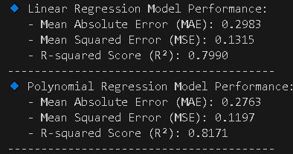
Lab Task No 1:

Solution:
Brief description (3-5 lines)
Write the above-mentioned program for iris dataset.
The code
# Import required libraries
import pandas as pd
from sklearn.model_selection import train_test_split
from sklearn.metrics import classification_report, confusion_matrix, accuracy_score
from sklearn.svm import SVC
# Load dataset
url = "https://raw.githubusercontent.com/jbrownlee/Datasets/master/iris.csv"
names = ['sepal-length', 'sepal-width', 'petal-length', 'petal-width', 'class']
dataset = pd.read_csv(url, names=names)
# Split-out validation dataset
array = dataset.values
X = array[:, 0:4] # Features
y = array[:, 4] # Target variable
# Split the data into training and validation sets
X_train, X_validation, Y_train, Y_validation = train_test_split(X, y, test_size=0.20, random_state=1)
# Create and train the SVM model
model = SVC(gamma='auto')
model.fit(X_train, Y_train)
# Make predictions on the validation dataset
predictions = model.predict(X_validation)
# Evaluate the model
print("Accuracy Score:")
print(accuracy_score(Y_validation, predictions))
print("\nConfusion Matrix:")
print(confusion_matrix(Y_validation, predictions))
print("\nClassification Report:")
print(classification_report(Y_validation, predictions))
The results (Screenshot)
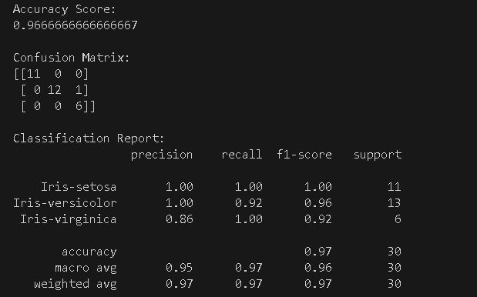

Conclusion
In conclusion, AI revolutionizes complex problem-solving by enabling machines to learn, adjust, and make intelligent decisions using advanced algorithms and computational models. However, effective implementation requires a strong understanding of machine learning, neural networks, and ethical issues. The most successful AI systems combine sophisticated computational techniques with contextual understanding, redefining the boundaries of intelligent systems. AI is not just a technological advancement but a deep exploration of intelligence, its acquisition, and the relationship between human creativity and machine capability.

